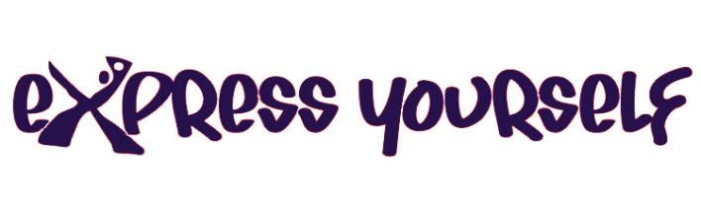
Application form
All information entered into this form will be treated confidentially. More information may be required during the programme. City Arts is registered under the Data Protection Act 1998.

Name of young person: | Date of birth:
Name of parent/ carer:
Phone Number: | Email:
Address: | Postcode:
Anything we need to be aware of:
medical/disabilities/dietary requirements

Would you like to be added to our mailing list? | Yes/No (delete as appropriate)

Referrer details
The referrer could be a professional (social worker, nurse, doctor, teacher, youth worker, etc.) or a parent/carer can fill this section in
Name: | Job title:
Address:  Postcode: | Telephone:
Email:

In what capacity do you know the young person:

Reason for referral:

What benefits do you hope the young person will gain from attending Express Yourself?

Signature:

Date:

Please forward to:
Alma Solarte-Tobon, City Arts, 11-13 Hockley, Nottingham, NG1 1FH
or via email: alma@city-arts.org.uk

